Date -

Experiment - 7
AJAX, JSON, JQUERY

PROGRAM 1:

AIM :
To create a DTD for a catalog of cars, heree each car has the cild elements make, model, year, color, engine, number_of_doors, transmission_type, and accessories. The engine element has the child elements number_of_cylinders and fuel_system (carburated or fuel injected). The accessories element has the attributes radio, air_conditioning, power_windows, power_steering, and power_brakes, each of which is required and has the possible values yes and no. Entities must be declared for the names of popular car models.

PROGRAM :

<?xml version="1.0" encoding="UTF-8"?>
<?xml-stylesheet type="text/xsl" href="Cars.xsl"?>
<!DOCTYPE note [
<!ELEMENT automobile (car+)>
<!ELEMENT car (make,model,year,color,engine,no_of_doors,transmission_type,accessories)>
<!ELEMENT engine (no_of_cylinders,fuel_systems)>
<!ATTLIST accessories radio CDATA #REQUIRED >
<!ATTLIST accessories air_condition CDATA #REQUIRED >
<!ATTLIST accessories power_window CDATA #REQUIRED >
<!ATTLIST accessories power_steering CDATA #REQUIRED >
<!ATTLIST accessories power_brake CDATA #REQUIRED >
]>

<catalog>
<car>
<make>Maruti</make>
<model>800</model>
<year>1999</year>
<color>Black</color>
<engine>
<number_of_cylinders>1</number_of_cylinders>
<fuel_system>fuel injected</fuel_system>
</engine>
<number_of_doors>4</number_of_doors>
<transmission_type>BB</transmission_type>
<accessories radio="Yes" air_conditioning="Yes" power_window="No" power_steering="Yes" power_brake="Yes"></accessories>
</car>

<car>
<make>Toyota</make>
<model>Camry</model>
<year>2018</year>
<color>Matte Black</color>
<engine>
<number_of_cylinders>1</number_of_cylinders>
<fuel_system>fuel injected</fuel_system>
</engine>
<number_of_doors>4</number_of_doors>
<transmission_type>BB</transmission_type>
<accessories radio="Yes" air_conditioning="Yes" power_window="No" power_steering="Yes" power_brake="Yes"></accessories>
</car>

<car>
<make>Toyota</make>
<model>Corolla</model>
<year>2016</year>
<color>Silver</color>
<engine>
<number_of_cylinders>1</number_of_cylinders>
<fuel_system>fuel injected</fuel_system>
</engine>
<number_of_doors>4</number_of_doors>
<transmission_type>BB</transmission_type>
<accessories radio="Yes" air_conditioning="Yes" power_window="No" power_steering="Yes" power_brake="Yes"></accessories>
</car>
</catalog>

OUTPUT :

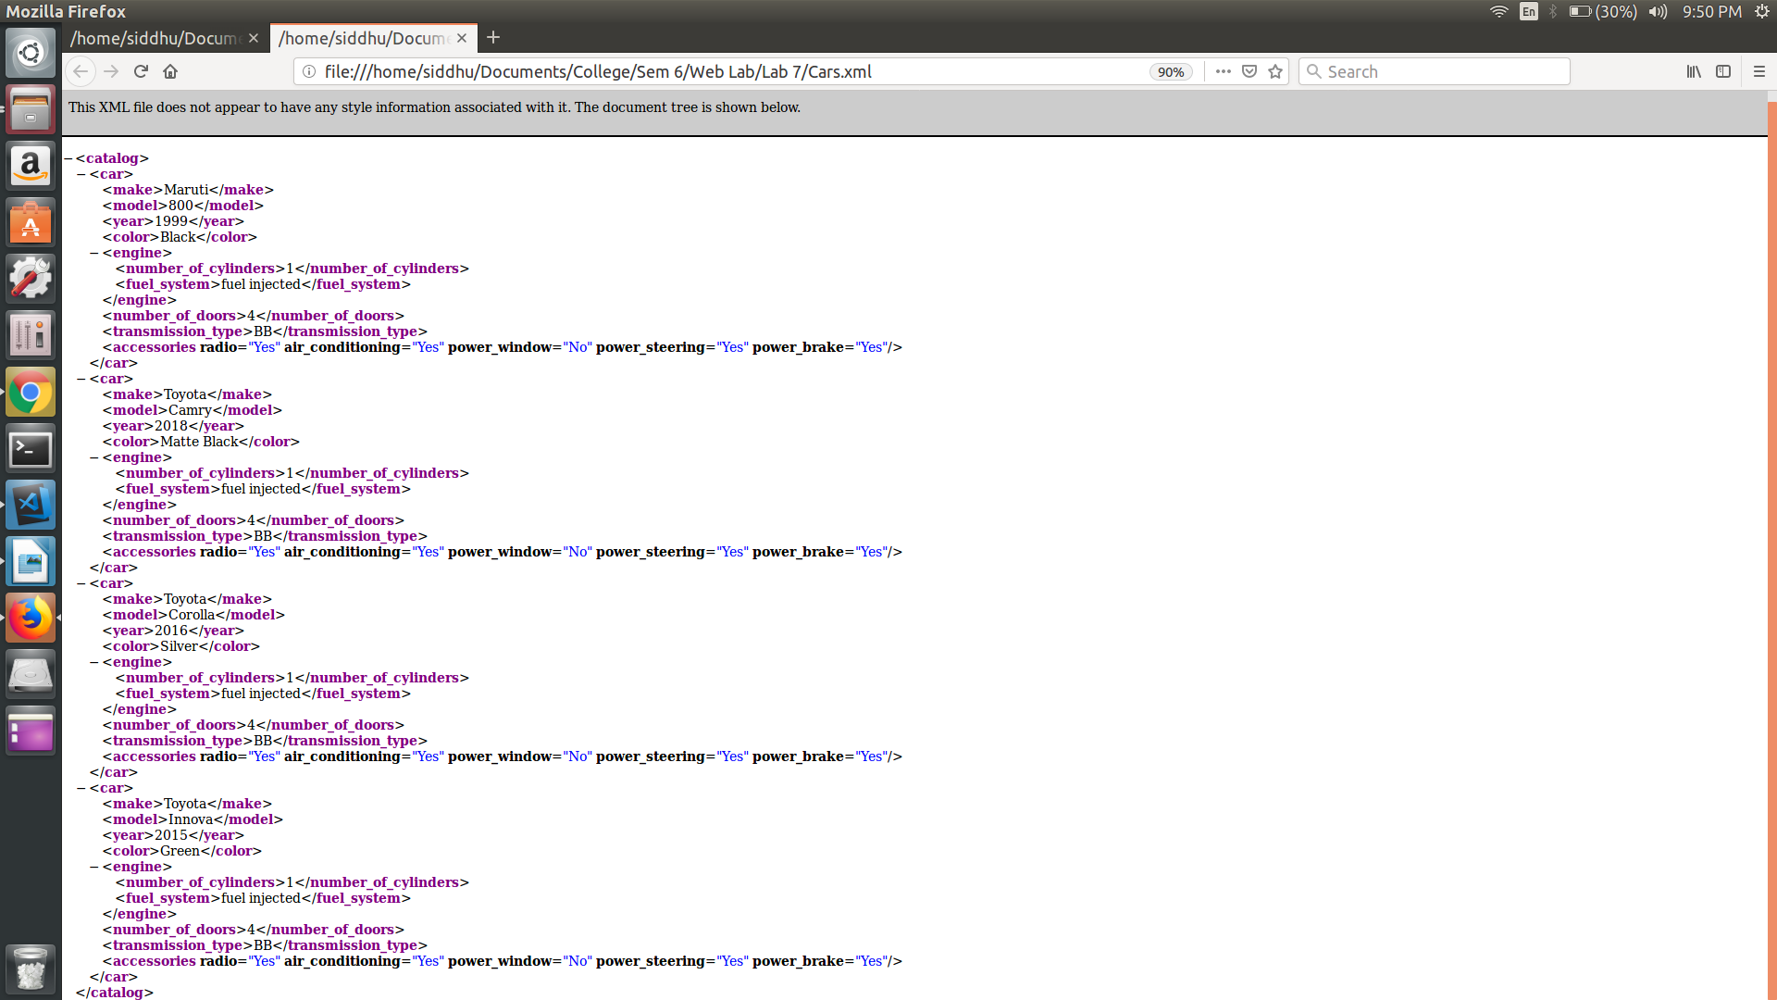

Result:
Thus the program is executed and output is obtained.
PROGRAM 2:

AIM :
To create an XML document with atleast three instances of the car element defined in the DTD of Program 1. Process the document by using the DTD of Program 1, and produce a display of raw XML document.

PROGRAM :

Cars.xml

<?xml version="1.0" encoding="UTF-8"?>
<?xml-stylesheet type="text/xsl" href="Cars.xsl"?>
<!DOCTYPE note [
<!ELEMENT automobile (car+)>
<!ELEMENT car (make,model,year,color,engine,no_of_doors,transmission_type,accessories)>
<!ELEMENT engine (no_of_cylinders,fuel_systems)>
<!ATTLIST accessories radio CDATA #REQUIRED >
<!ATTLIST accessories air_condition CDATA #REQUIRED >
<!ATTLIST accessories power_window CDATA #REQUIRED >
<!ATTLIST accessories power_steering CDATA #REQUIRED >
<!ATTLIST accessories power_brake CDATA #REQUIRED >
]>
<catalog>
<car>
<make>Maruti</make>
<model>800</model>
<year>1999</year>
<color>Black</color>
<engine>
<number_of_cylinders>1</number_of_cylinders>
<fuel_system>fuel injected</fuel_system>
</engine>
<number_of_doors>4</number_of_doors>
<transmission_type>BB</transmission_type>
<accessories radio="Yes" air_conditioning="Yes" power_window="No" power_steering="Yes" power_brake="Yes"></accessories>
</car>

<car>
<make>Toyota</make>
<model>Camry</model>
<year>2018</year>
<color>Matte Black</color>
<engine>
<number_of_cylinders>1</number_of_cylinders>
<fuel_system>fuel injected</fuel_system>
</engine>
<number_of_doors>4</number_of_doors>
<transmission_type>BB</transmission_type>
<accessories radio="Yes" air_conditioning="Yes" power_window="No" power_steering="Yes" power_brake="Yes"></accessories>
</car>

<car>
<make>Toyota</make>
<model>Corolla</model>
<year>2016</year>
<color>Silver</color>
<engine>
<number_of_cylinders>1</number_of_cylinders>
<fuel_system>fuel injected</fuel_system>
</engine>
<number_of_doors>4</number_of_doors>
<transmission_type>BB</transmission_type>
<accessories radio="Yes" air_conditioning="Yes" power_window="No" power_steering="Yes" power_brake="Yes"></accessories>
</car>

<car>
<make>Toyota</make>
<model>Innova</model>
<year>2015</year>
<color>Green</color>
<engine>
<number_of_cylinders>1</number_of_cylinders>
<fuel_system>fuel injected</fuel_system>
</engine>
<number_of_doors>4</number_of_doors>
<transmission_type>BB</transmission_type>
<accessories radio="Yes" air_conditioning="Yes" power_window="No" power_steering="Yes" power_brake="Yes"></accessories>
</car>

</catalog>

Cars.xsl

<?xml version="1.0" encoding="UTF-8"?>
<xsl:stylesheet version="1.0"
xmlns:xsl="http://www.w3.org/1999/XSL/Transform">
<xsl:template match="/">
<html>
<body>
<h2>Cars catalog</h2>
<table border="1">
<tr bgcolor="#9acd32">
<th style="text-align:left">Make</th>
<th style="text-align:left">Model</th>
<th style="text-align:left">Year</th>
<th style="text-align:left">Color</th>
<th style="text-align:left">Engine</th>
<th style="text-align:left">Doors</th>
<th style="text-align:left">Transmission Types</th>
<th style="text- align:left">Accessories</th>
<!-- <th style="text-align:left"></th> -->

</tr>
<xsl:for-each select="catalog/car">
<tr>
<td>
<xsl:value-of select="make"/>
</td>
<td>
<xsl:value-of select="model"/>
</td>
<td>
<xsl:value-of select="year"/>
</td>
<td>
<xsl:value-of select="color"/>
</td>
<td>
<xsl:value-of select="engine"/>
</td>
<td>
<xsl:value-of select="number_of_doors"/>
</td>
<td>
<xsl:value-of select="transmission_type"/>
</td>
<td>
<xsl:value-of select="accessories"/>
</td>
</tr>
</xsl:for-each>
</table>
</body>
</html>
</xsl:template>
</xsl:stylesheet>

OUTPUT :

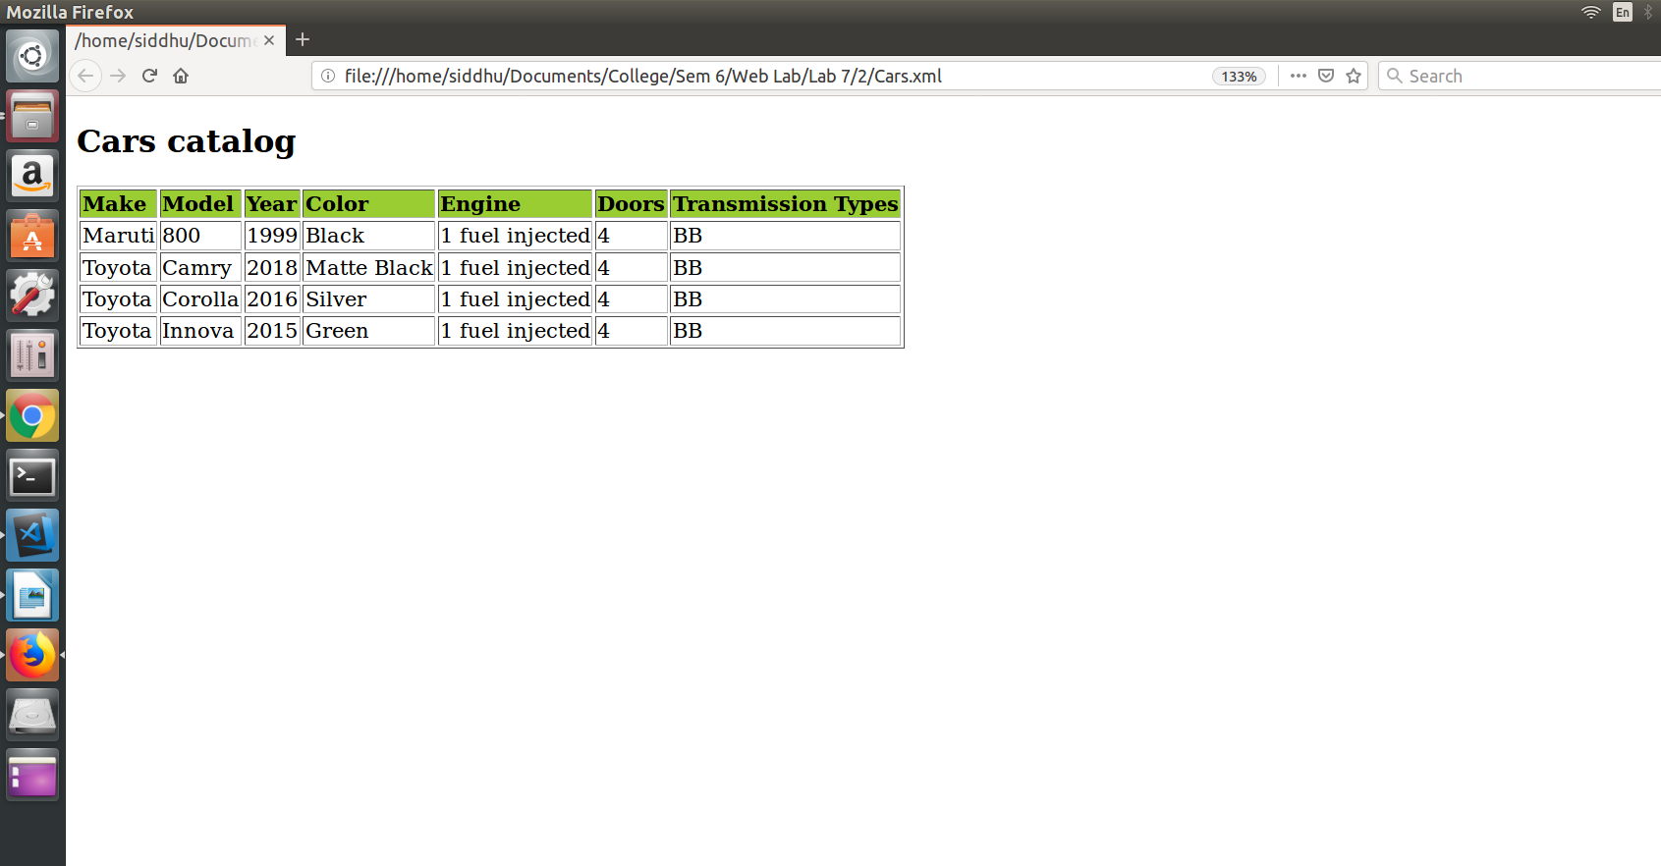

Result:
Thus the program is executed and output is obtained.

PROGRAM 3:

Aim:
To modify the example application of Program 1 to allow the user to select a make and model of used cars. The make must be in a menu. When a make is chosen, a meny of models must be displayed. This menu is produced by hardwired data in the original document. When a model is chosen, an AJAX request must be made to get a list of the years and colors of the chosen make and model that are available. Make up a server-resident script to produce the data from an example array or hash.

PROGRAM :

<html>
<head>
<title> Program 3 </title>
<style>
#display{
visibility: hidden;
}
</style>
<script>
function getData(){
var xml_load1 = new XMLHttpRequest();
xml_load1.onreadystatechange = function(){
if(this.readyState == 4 && this.status == 200){
getMakeElement(this);
}
};
xml_load1.open("GET","index.xml",true);
xml_load1.send();
}
function getMakeElement(xml){
var xmlDoc = xml.responseXML;
var content = "";
var x = xmlDoc.getElementsByTagName("make");
for(i = 0;i < x.length;i++){
var name = "button"+i.toString();
var id1 = "value"+i.toString();
content += "<br> <input type = 'text'" + "value='" + x[i].childNodes[0].nodeValue + "' id=" + id1+ " /><button id="+name+" onclick = displayUtil('" + x[i].childNodes[0].nodeValue + "')> Click to display value </button><br>";
}
document.getElementById("list").innerHTML = content;
}
function displayUtil(name){
document.getElementById("list").style.visibility = "hidden";
document.getElementById("list").style.display = "none";
console.log(name);
getContentData(name)

}
function getContentData(data){
var xml_load1 = new XMLHttpRequest();
xml_load1.onreadystatechange = function(){
if(this.readyState == 4 && this.status == 200){
loadData(this,data);
}
};
xml_load1.open("GET","index.xml",true);
xml_load1.send();
}
function loadData(xml,data){
var xmlDoc = xml.responseXML;
var content = "<table border=1><tr><th>Color</th><th>Year</th></tr>";
var x = xmlDoc.getElementsByTagName("car");
for(var i = 0;i<x.length;i++){
if(x[i].getElementsByTagName("make") [0].childNodes[0].nodeValue == data){
content+="<tr><td>"+ x[i].getElementsByTagName("color") [0].childNodes[0].nodeValue + "</td><td>"+ x[i].getElementsByTagName("year") [0].childNodes[0].nodeValue + "</td></tr>";
}
}
content+="</table>";
document.getElementById("display").innerHTML = content;
document.getElementById("display").style.visibility = "visible";
}

</script>
</head>
<body onload = "getData()">
<div id="list">
</div>
<div id = "display">
</div>
</body>
</html>

index.xml

<catalog>
<car>
<make>Indian</make>
<model>BMW</model>
<color>Blue</color>
<year>1992</year>
<engine>
<number_of_cylinders>6</number_of_cylinders>
<fuel_system>fuel injected</fuel_system>
</engine>
<number_of_doors>4</number_of_doors>
<transmission_type>automatic</transmission_type>
<accessories radio = "yes" air_conditioning = "no" power_windows = "yes" power_steering = "no" power_brakes = "yes"></accessories>
</car>

<car>
<make>English</make>
<model>Benz</model>
<color>Black</color>
<year>1985</year>
<engine>
<number_of_cylinders>8</number_of_cylinders>
<fuel_system>carburated</fuel_system>
</engine>
<number_of_doors>2</number_of_doors>
<transmission_type>manual</transmission_type>
<accessories radio = "yes" air_conditioning = "no" power_windows = "yes" power_steering = "no" power_brakes = "yes"></accessories>
</car>
<car>
<make>German</make>
<model>Volkswagon</model>
<color>Red</color>
<year>1999</year>
<engine>
<number_of_cylinders>4</number_of_cylinders>
<fuel_system>carburated</fuel_system>
</engine>
<number_of_doors>6</number_of_doors>
<transmission_type>auto</transmission_type>
<accessories radio = "yes" air_conditioning = "no" power_windows = "yes" power_steering = "no" power_brakes = "yes"></accessories>
</car>
</catalog>
OUTPUT :

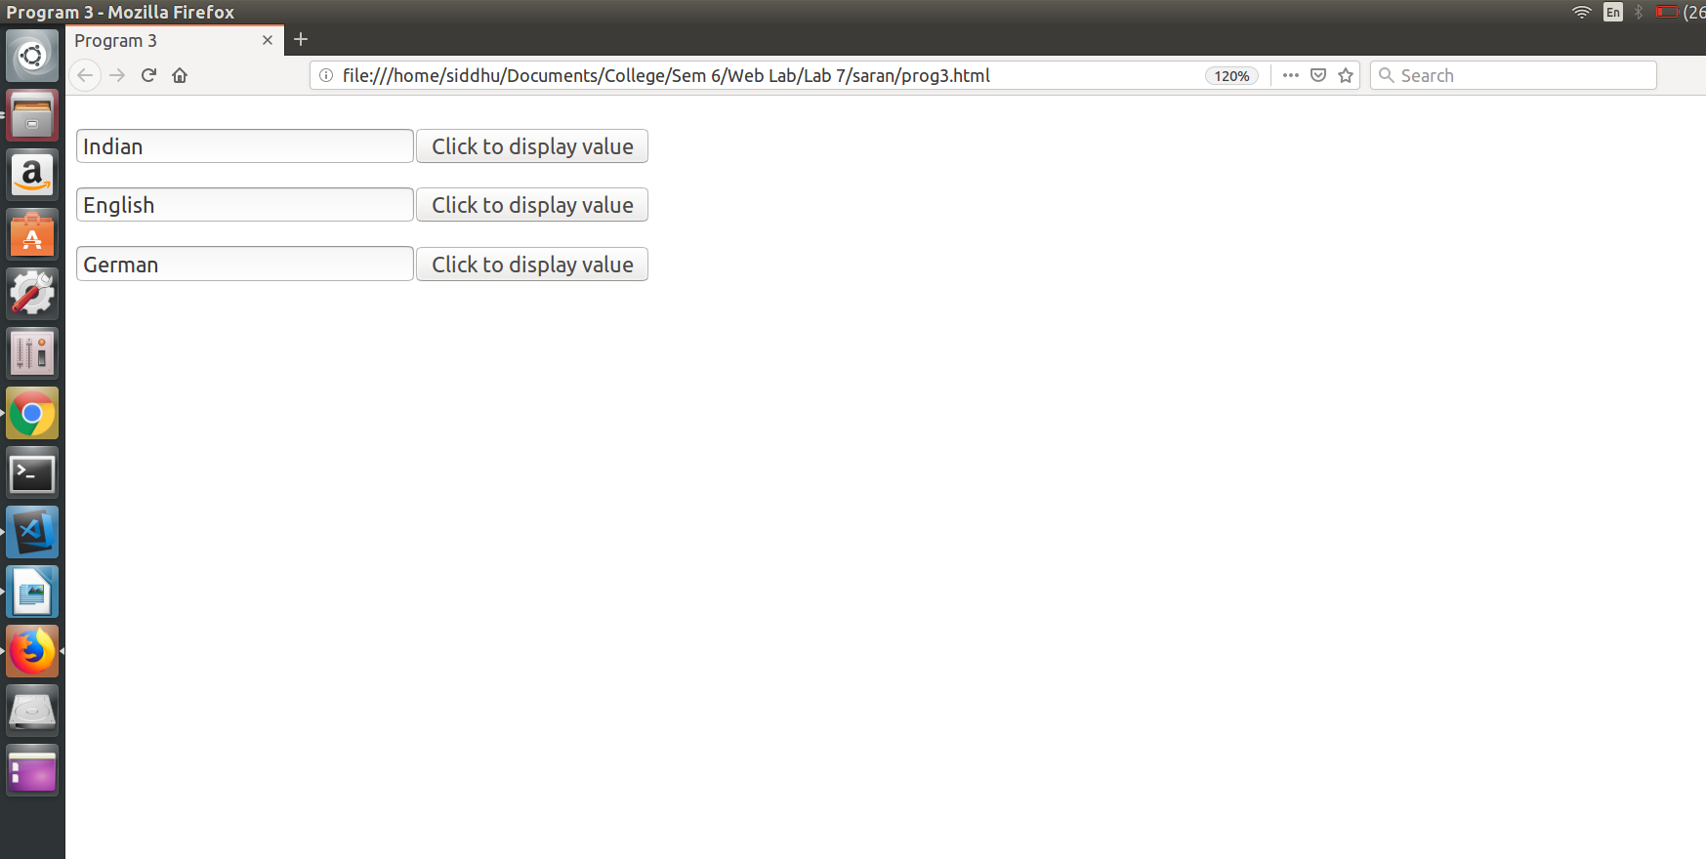
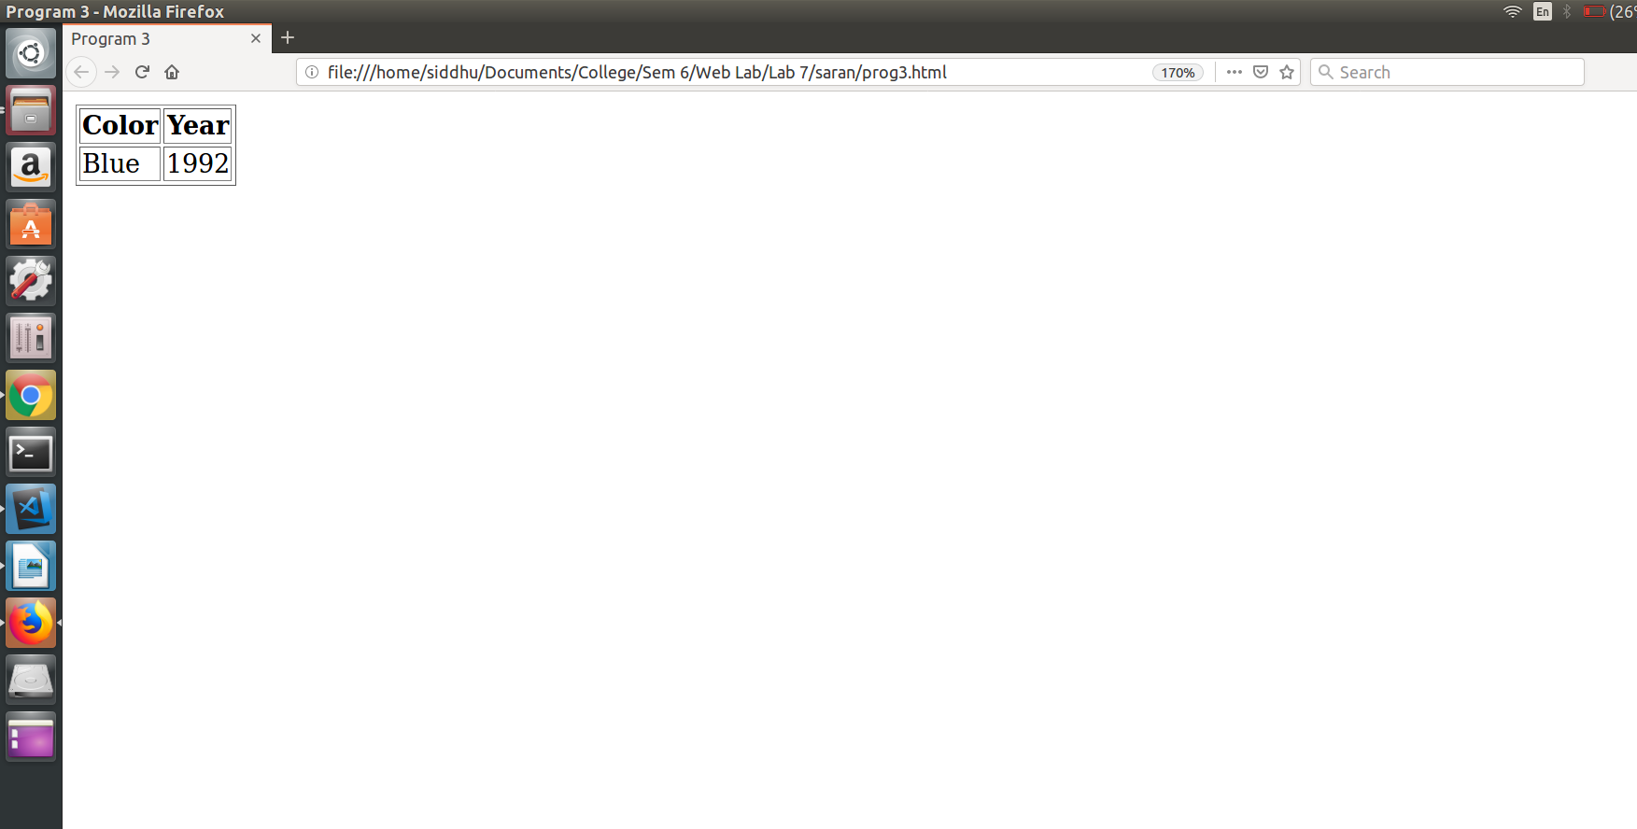
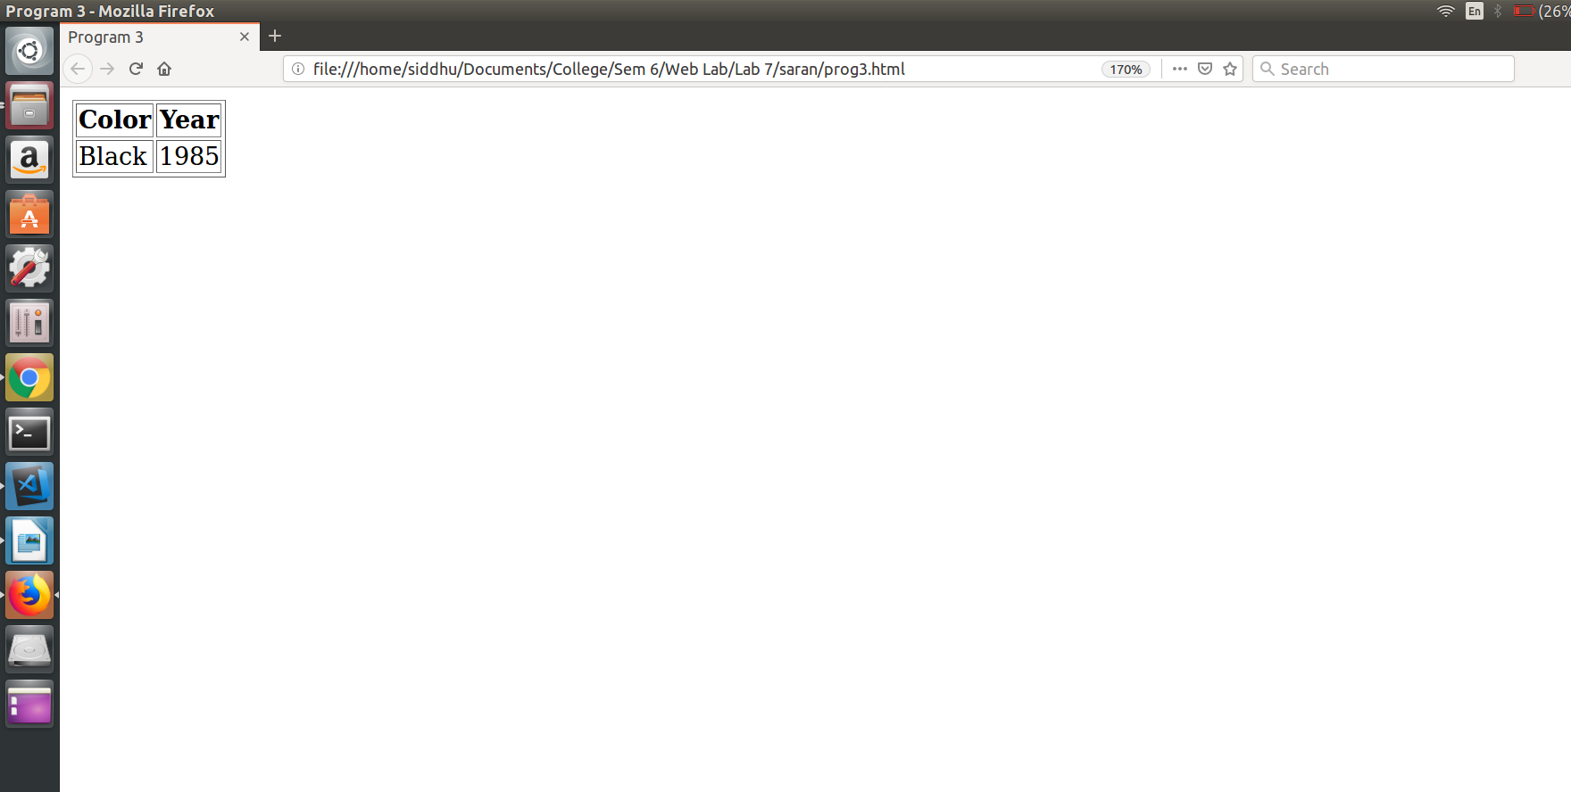

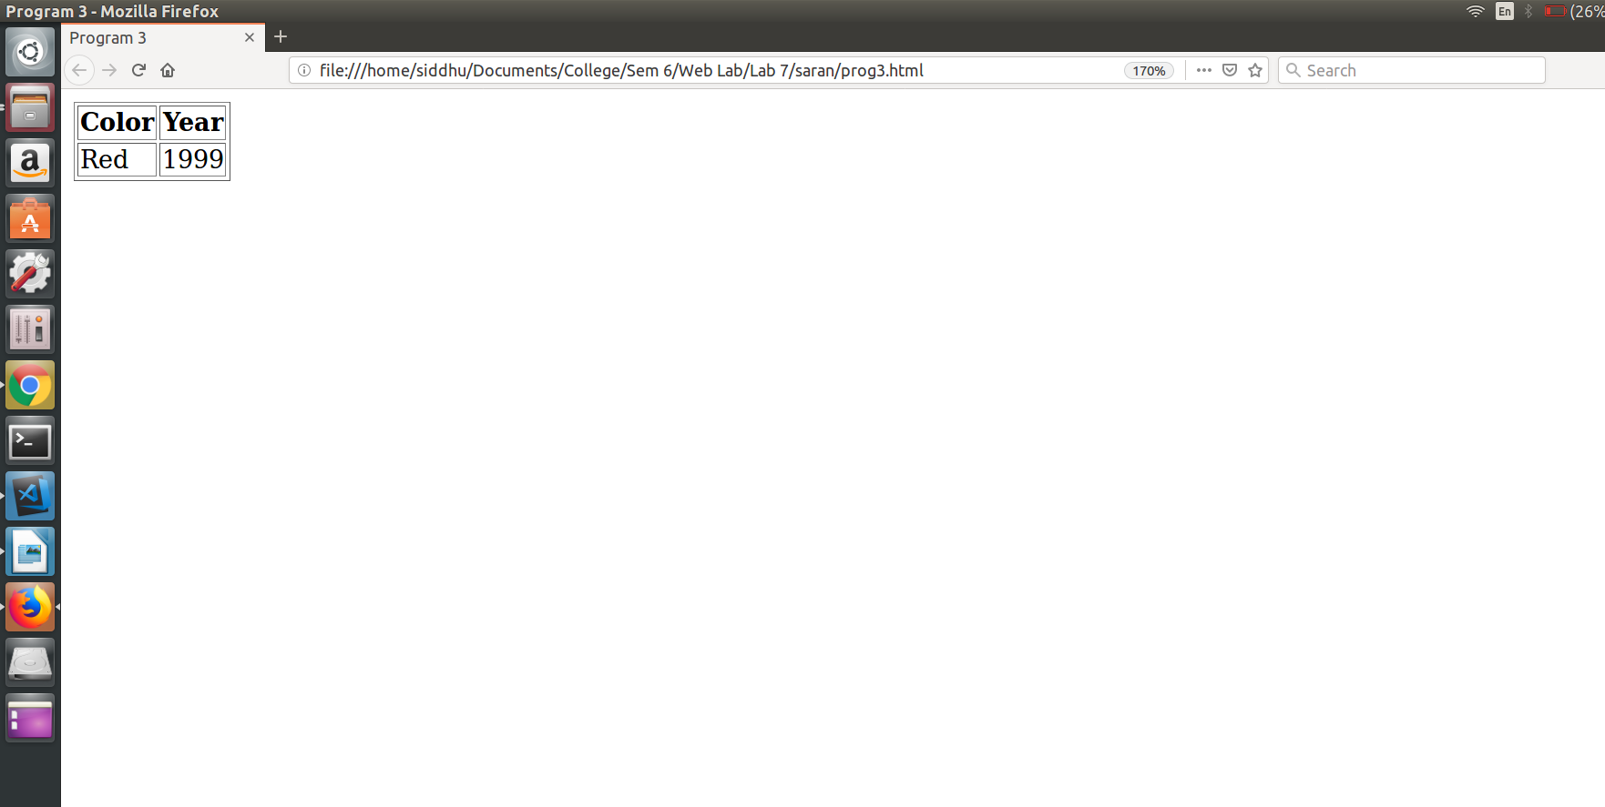

Result:
Thus the program is executed and output is obtained.

PROGRAM 4:

Aim:
To modify the example application of Program 1 to have it provide the addresses of repeat customers, using a hash of names and addresses.

PROGRAM :

Prog4.dtd :

<!ELEMENT catalog (car,customers)>
<!ELEMENT car (make, model, year, color, engine, number_of_doors, transmission_type, accessories)>
<!ELEMENT make (#PCDATA)>
<!ELEMENT model (#PCDATA)>
<!ELEMENT year (#PCDATA)>
<!ELEMENT color (#PCDATA)>
<!ELEMENT engine (number_of_cylinders,fuel_system)>
<!ELEMENT number_of_cylinders (#PCDATA)>
<!ELEMENT fuel_system (#PCDATA)>
<!ELEMENT number_of_doors (#PCDATA)>
<!ELEMENT transmission_type (#PCDATA)>
<!ELEMENT accessories (#PCDATA)>
<!ATTLIST accessories radio (yes|no)>
<!ATTLIST accessories air_conditioning (yes|no)>
<!ATTLIST accessories power_windows (yes|no)>
<!ATTLIST accessories power_steering (yes|no)>
<!ATTLIST accessories power_brakes (yes|no)>
<!ELEMENT customers (id,name,address,count)>
<!ELEMENT id (#PCDATA)>
<!ELEMENT name (#PCDATA)>
<!ELEMENT address (city,state,zipcode)>
<!ELEMENT city (#PCDATA)>
<!ELEMENT catalog (#PCDATA)>
<!ELEMENT catalog (#PCDATA)>
<!ELEMENT count (#PCDATA)>

Prog4.xml

<?xml version="1.0"?>
<!DOCTYPE catalog SYSTEM "prog4.dtd">
<catalog>
<car>
<year>1998</year>
<make>Indian</make>
<model>BMW</model>
<color>Blue</color>
<engine>
<number_of_cylinders>6</number_of_cylinders>
<fuel_system>fuel_injected</fuel_system>
</engine>
<transmission_type>auto</transmission_type>
<number_of_doors>4</number_of_doors>
<accessories radio = "yes" air_conditioning = "no" power_windows = "yes" power_steering = "no" power_brakes = "yes"></accessories>
</car>

<car>
<make>English</make>
<model>Benz</model>
<year>1912</year>
<color>Black</color>
<engine>
<number_of_cylinders>8</number_of_cylinders>
<fuel_system>carburated</fuel_system>
</engine>
<number_of_doors>2</number_of_doors>
<transmission_type>manual</transmission_type>
<accessories radio = "yes" air_conditioning = "no" power_windows = "yes" power_steering = "no" power_brakes = "yes"></accessories>
</car>

<customer>
<id>1</id>
<name>Harry</name>
<address>
<city>Albany</city>
<state>New York</state>
<zip>10001</zip>
</address>
</customer>

<customer>
<id>2</id>
<name>Lily Potter</name>
<address>
<city>Albany</city>
<state>New York</state>
<zip>10001</zip>
</address>
</customer>
</catalog>

Prog4.html

<!DOCTYPE html>
<html>
<head>
<meta charset="utf-8">
<meta http-equiv="X-UA-Compatible" content="IE=edge">
<title>Repeat Customers</title>
<meta name="viewport" content="width=device-width, initial-scale=1">
</head>
<body>
<input type="button" value="Display Frequent" onclick=dispData()>
<br>
<br>
<p id="demo"></p>

<script>
function inputData() {
var id = document.getElementById("id");
var name = document.getElementById("name");
var city = document.getElementById("city");
var state = document.getElementById("state");
var zip = document.getElementById("zip");

var xhttp = new XMLHttpRequest();
xhttp.onreadystatechange = function() {
if(this.readyState == 4 && this.status == 200) {
alert(this.responseText);
document.getElementById("demo").innerHTML = this.responseText;
}
};
xhttp.open("GET","prog4.php?id=" + id,true);
xhttp.send();
}
function dispData() {
var xhttp = new XMLHttpRequest();
xhttp.onreadystatechange = function() {
if(this.readyState == 4 && this.status == 200) {
dispXML(this);
}
};
xhttp.open("GET","prog4.xml",true);
xhttp.send();
}

function dispXML(xml) {
var xmlDoc = xml.responseXML;
var x = xmlDoc.getElementsByTagName("customer");

var content = "";

alert(x.length);
for (var i = 0; i < x.length; i++) {
console.log(i);
content += "Name: " + x[i].getElementsByTagName("name")[0] .childNodes[0].nodeValue + " <br>";
content += "Address: <br>"

var y = x[i].getElementsByTagName("address");

for (var j = 0; j < y.length; j++) {
content += "City: " + y[j].getElementsByTagName("city")[0].childNodes[0].nodeValue + " <br>";
content += "State: " + y[j].getElementsByTagName("state")[0].childNodes[0].nodeValue + " <br>";
content += "Pincode: " + y[j].getElementsByTagName("zip")[0].childNodes[0].nodeValue + " <br>";
}
content += "<br>"
}
document.getElementById("demo").innerHTML = content;

}
</script>

</body>
</html>

OUTPUT :

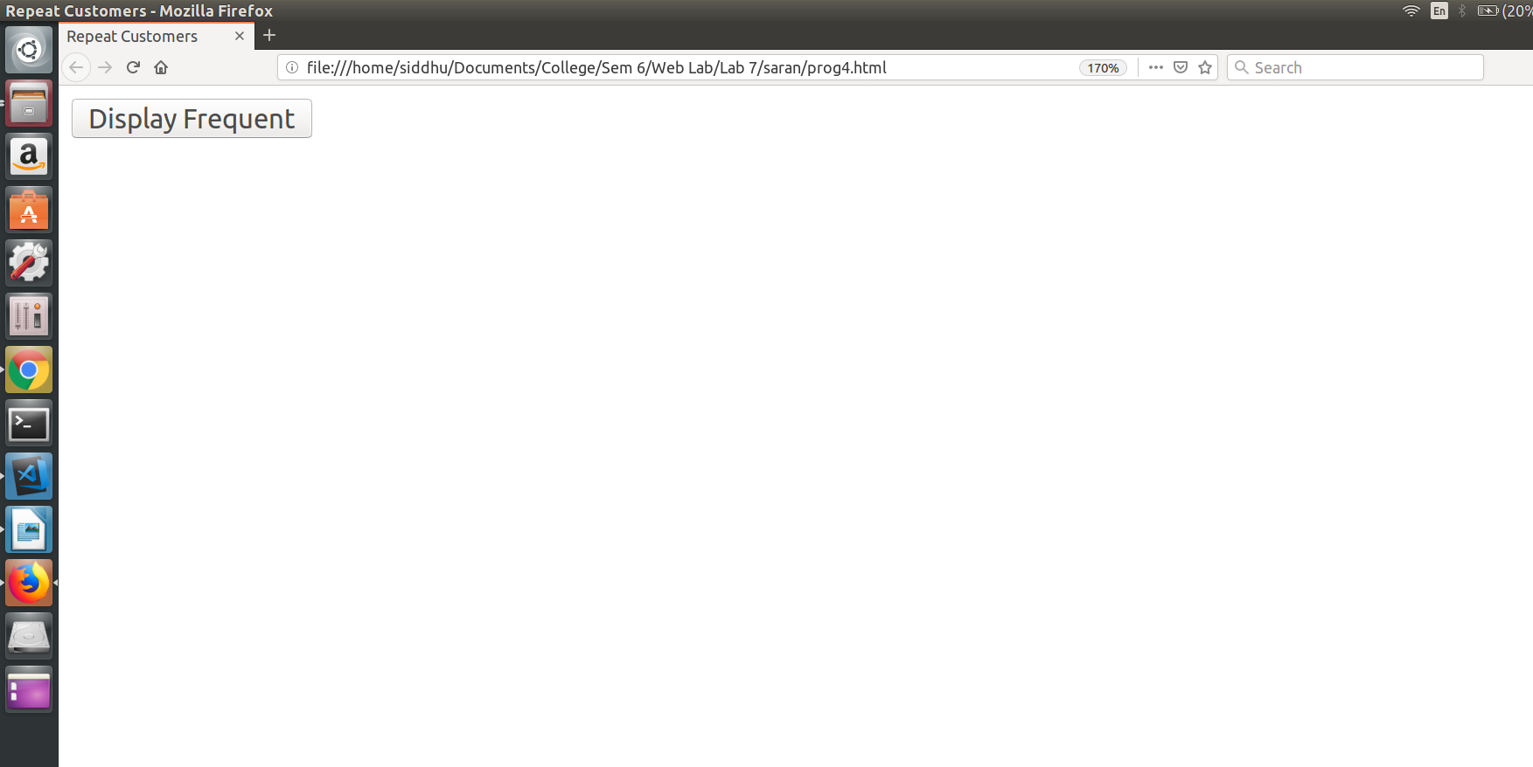
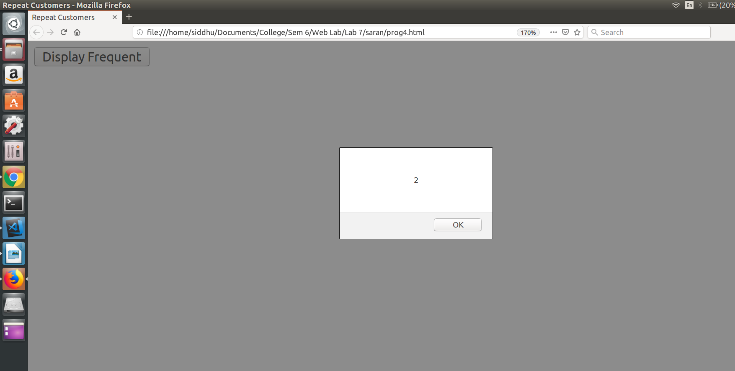
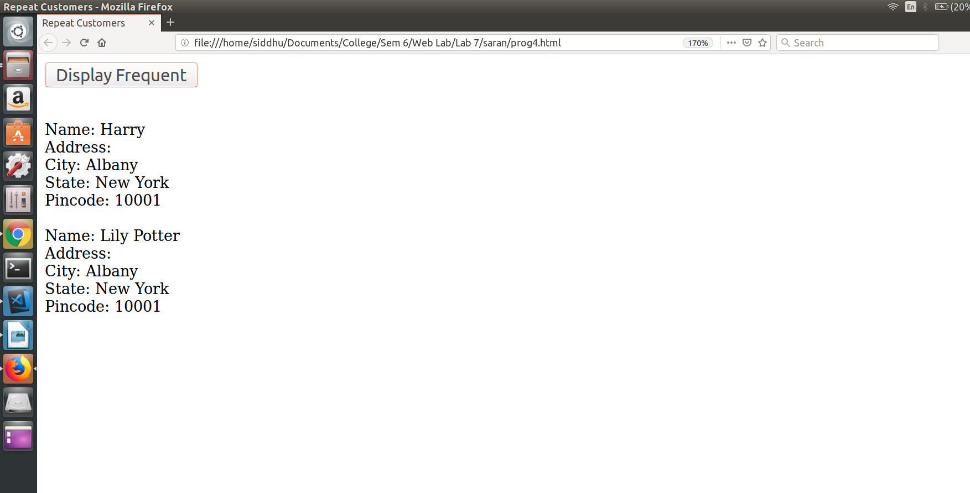

Result:
Thus the program is executed and output is obtained.

PROGRAM 5:

Aim:
To modify the example application of Program 4 with validate the zip code when it is entered, to ensure that it is a valid zip code for the given city and state. The response document can be a PHP script that looks up the zip code and the city and state in a small table of examples.

PROGRAM :

Prog5.html

<html>
<head>
<title>Program 5</title>
<meta charset="utf-8">
<script>
function myfunc(){
var x = document.getElementById("city").value;
var y = document.getElementById("state").value;
var z = document.getElementById("zipcode").value;
console.log(x);
var req = x + " " + y + " " + z;
var xml_load1 = new XMLHttpRequest();
xml_load1.onreadystatechange = function(){
if(this.readyState == 4 && this.status == 200){
}
};
xml_load1.open("GET","prog5.php? val="+req,true);
xml_load1.send();
}
</script>
</head>
<body>
<form>
City:<input id="city" type="text" value="" /><br><br>
State:<input id="state" type="text" value="" /><br><br>
ZipCode:<input id="zipcode" type="text" value="" /><br><br>
<input type="button" value="Submit" onclick=myfunc() />
</form>
</body>
</html>

Prog5.php

<?php
$address[] = "Chennai TamilNadu 600001";
$address[] = "Salem TamilNadu 600002";
$address[] = "Madurai TamilNadu 600003";

$val = $_REQUEST["val"];
$fl = 0;
for($i=0;$i<sizeof($address);$i++){
if($address[$i] == $val){
$fl = 1;
break;
}
}
if($fl==0)
echo 'inValid';
else
echo 'valid';
?>

OUTPUT :

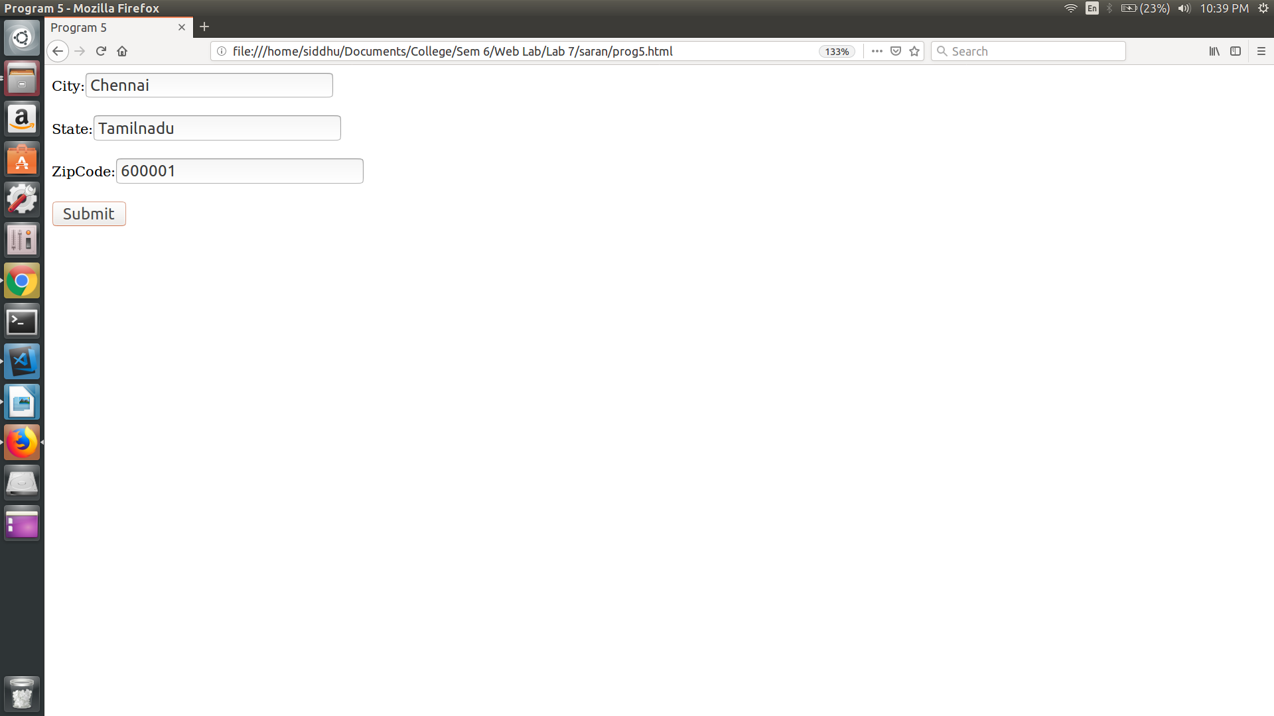
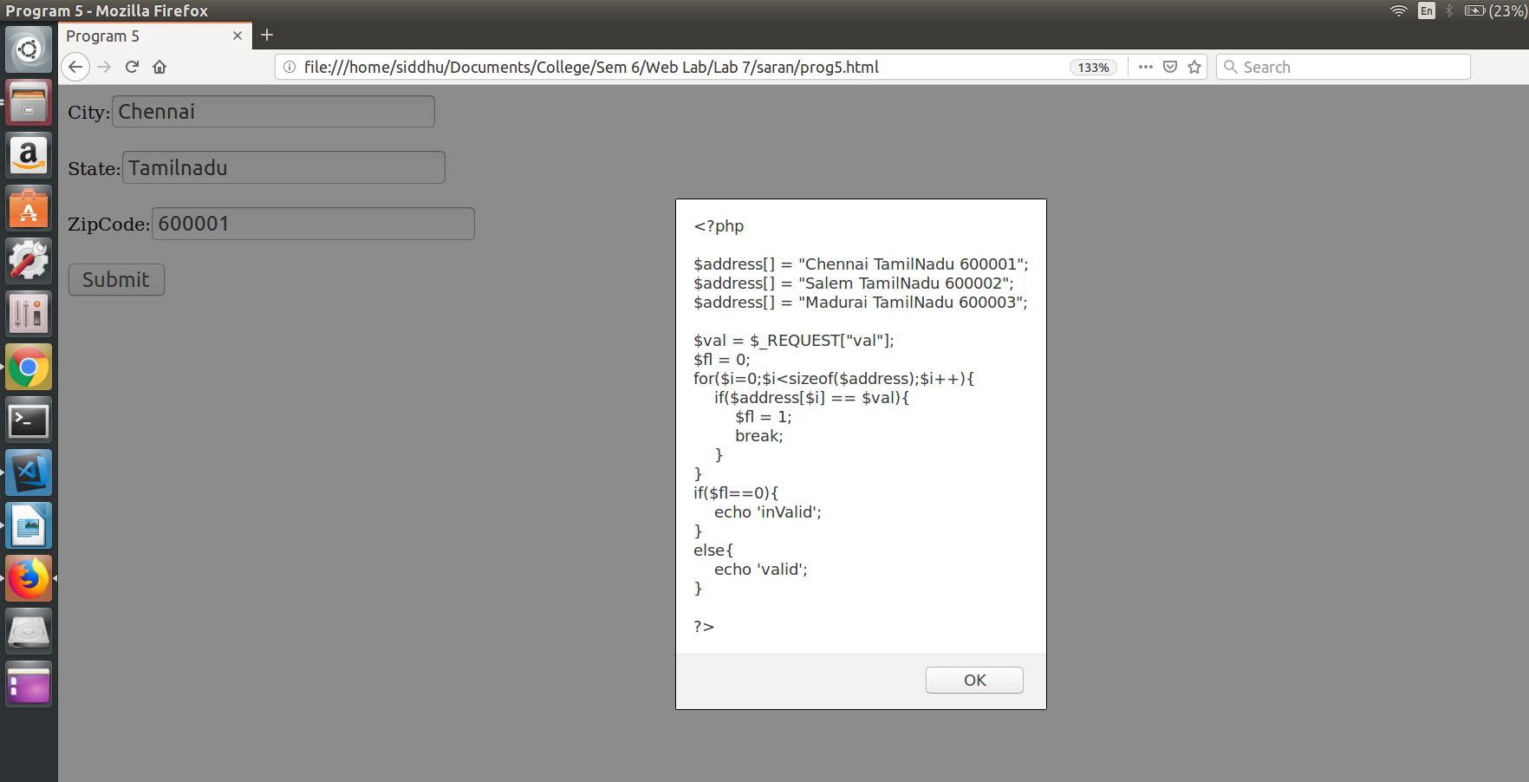

Result:
Thus the program is executed and output is obtained.

